Come Learn More Sheep Stuff & Have Fun
2022 N-CSA Annual Meeting
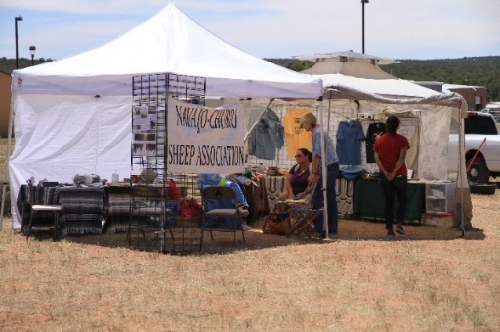
Date: October 15-16, 2022
Note: The AGM Location has changed to:
Where: Old Spanish Trail Arena
3641 S. Highway 191
Moab, UT 84532

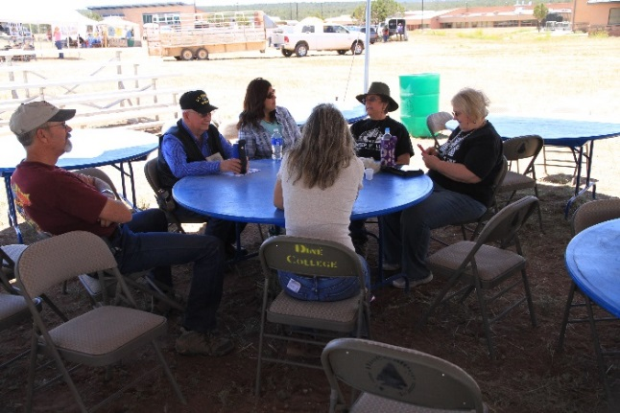
Two days of great information on:
1. General nutrition
2. The Big Picture / When to cull – Why to keep / Selecting a breeding ram.
3. Sheep Show & Inspection Workshop
4. Marketing: How to choose, produce & sell a product;
sheep, wool, meat. & other goods
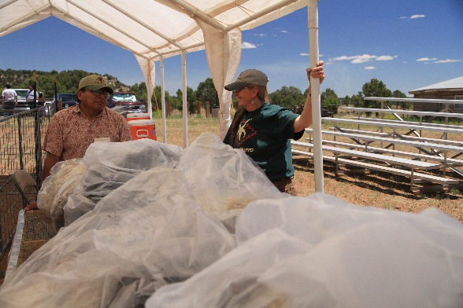
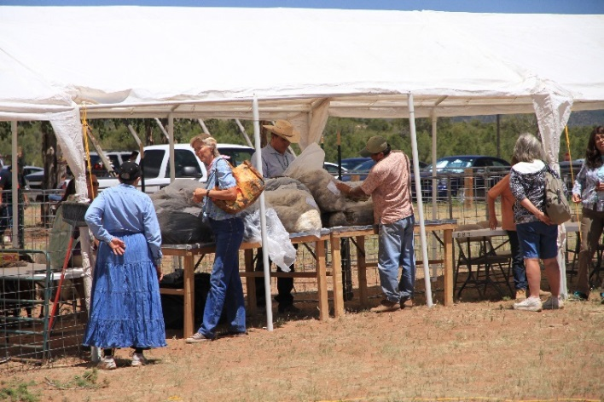
5. Fleece Show

***All meals will be catered by Canyon Steak & Waffle House from Moab ***
Look for more info on pricing and signing up in summer issues of The Catch Pen, on our website, Churro Chat, and other media.
We hope to see you there!!!
Or follow the meeting on Zoom.

